
BRCA2 (2213-2543)
Catalog Number: CR-M26364-3
Gene Symbol: BRCA2, BRCC2, FAD1,FCD, BROVCA2, PNCA2
Description: Anti-BRCA2 (2213-2543) Mouse Monoclonal Antibody

Background: BRCA2 is a human tumor
suppressor gene. Its protein, also called by
the synonym breast cancer type 2 susceptibility protein, is responsible for repairing DNA.
Mutations of BRCA2 can cause an increased risk of breast cancer. In addition to breast cancer in
men and women, mutations in BRCA2 also lead
to an increased risk of ovarian,Fallopian
tube, prostate, and pancreatic cancers, as well as malignant melanoma .
Immunogen: Purified BRCA2 (2213-2543) protein, human origin.
Tested applications: ELISA, WB, IHC Recommended dilutions:
ELISA: 1:1000-1:2000
WB: 1:500-1:1000
IHC: 1:50-1:100
Concentration: 1 mg/ml
Host: Mouse
Clonality: Monoclonal
Purity: Purified from ascites
Format: Liquid Storage buffer:
Preservative: no
Constituents: PBS (without Mg2+ and Ca2+), pH
7.4, 150 mM NaCl, 50% glycerol
Species Reactivity: Recognizes
BRCA2(2213-2543) of vertebrates.
Storage Conditions: Store at -20°C. Avoid freeze / thaw cycles.

Western blot:
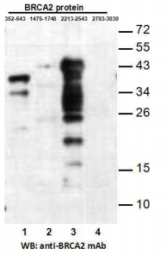
Western blot analysis of recombinant BRCA2 proteins. Purified His-tagged BRCA2 (352-643) protein (lane1), His-tagged BRCA2 (1475-1748)
protein(lane2),His-tagged BRCA2 (2213-2543) protein(lane3) and His-tagged BRCA2
(2793-3030) protein (lane4) were blotted with anti-BRCA2 (2213-2543) monoclonal antibody (Cat. #26364-3).

For research use only. Not for diagnostic or therapeutic applications.

Immunofluorescence:
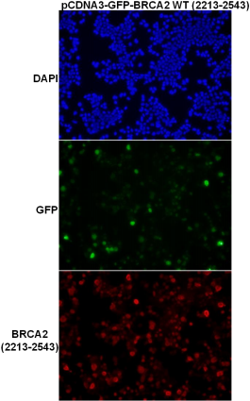
Immunofluorescence of cells expressing
BRCA2（2213-2543）protein with anti-BRCA2 (2213-2543) antibody. HEK293T cells was
transfected with pCDNA3-GFP-BRCA2
(2213-2543) plasmid, then fixed and stained with anti-BRCA2 (2213-2543) monoclonal antibody (Cat. #26364-3).

