
BRCA1 (1720-1863)
Catalog Number: CR-M26351-2
Gene Symbol: BRCA1, BRCC1, IRIS, PNCA4, PPP1R53, PSCP
Description: Anti-BRCA1 (1720-1863) Mouse Monoclonal Antibody

Background: BRCA1 is normally expressed in
cells of breast and other tissues, where it helps
repair damaged DNA or destroy cells if DNA
cannot be repaired. It is involved in the repair of
chromosomal damage with an important role in
the error-free repair of DNA double-strand breaks. If BRCA1 itself is damaged by a BRCA1
mutation, damaged DNA is not repaired properly, and this increases the risk for breast cancer.
Immunogen: Purified BRCA1 (1720-1863) protein, human origin.
Tested applications: ELISA, WB, IHC Recommended dilutions:
ELISA: 1:1000-1:2000
WB: 1:500-1:1000
IHC: 1:50-1:100
Concentration: 1 mg/ml
Host: Mouse
Clonality: Monoclonal
Purity: Purified from ascites
Format: Liquid Storage buffer:
Preservative: no
Constituents: PBS (without Mg2+ and Ca2+), pH
7.4, 150 mM NaCl, 50% glycerol
Species Reactivity: Recognizes
BRCA1(1720-1863) of vertebrates.
Storage Conditions: Store at -20°C. Avoid freeze / thaw cycles.

Western blot:
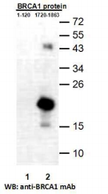
Western blot analysis of recombinant BRCA1 (1-120) and BRCA1 (1720-1863) proteins.
Purified His-tagged BRCA1 (1-120) protein
(lane1) and corresponding His-tagged BRCA1 (1720-1831) (lane2) were blotted with
anti-BRCA1 (1720-1863) monoclonal antibody (Cat. #26351-2).

For research use only. Not for diagnostic or therapeutic applications.

Immunofluorescence:
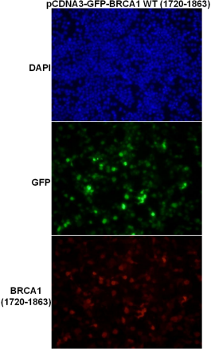

Immunofluorescence of cells expressing
BRCA1（1720-1863）protein with anti-BRCA1 (1720-1863) antibody. HEK293T cells was
transfected with pCDNA3-GFP-BRCA1
(1720-1863) plasmid, then fixed and stained with anti-BRCA1 (1720-1863) monoclonal antibody (Cat. #26351-2).

