
RET (C634Y)
Catalog Number: CR-M26146
Gene Symbol: RET, PTC, CDHF12, CAHF16, HSCR1, MEN2A, MEN2B
Description: Anti-RET (C634Y) Mouse Monoclonal Antibody

Background: RET protein is encoded by the
RET proto- oncogene. It is a receptor tyrosine
kinase. RET loss of function mutations are
associated with the development of
Hirschsprung’s disease, while gain of function
mutations are associated with development of
various types of human cancer, including
medullary thyroid carcinoma, multiple endocrine neoplasias type 2A and 2B, pheochromocytoma and parathyroid hyperplasia.
Immunogen: A synthetic peptide from the internal region ofRET which includes the mutation ofC634Y, human origin.
Tested applications: ELISA, WB, IHC Recommended dilutions:
ELISA: 1:1000-1:2000
WB: 1:500-1:1000
IHC: 1:50-1:100
Concentration: 0.5 mg/ml
Host: Mouse
Clonality: Monoclonal
Purity: Purified from ascites
Format: Liquid Storage buffer:
Preservative: no
Constituents: PBS (without Mg2+ and Ca2+), pH 7.4, 150 mM NaCl, 50% glycerol
Species Reactivity: Recognizes C634Y mutant, but not wild-type RET of vertebrates.
Storage Conditions: Store at -20°C. Avoid freeze / thaw cycles.

Western blot:
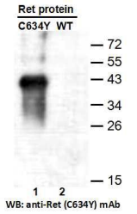
Western blot analysis of recombinant RET (C634Y) and wildtype proteins. Purified
His-tagged RET (C634Y) protein (lane1) and corresponding wild-type protein (lane2) were blotted with anti-RET (C634Y) monoclonal antibody (Cat. #26146).

For research use only. Not for diagnostic or therapeutic applications.

Immunofluorescence:
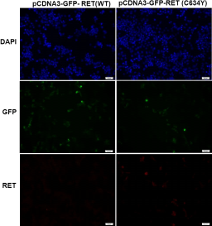
Immunofluorescence of cells expressing RET proteins with anti-RET (C634Y) antibody.
HEK293T cells were transfected with
pCDNA3-GFP-RET (WT) plasmid (left column) or pCDNA3-GFP-RET (C634Y) plasmid (right column), then fixed and stained with anti-RET
(C634Y) monoclonal antibody (Cat. #26146).

