EGFR (G863D)
Catalog Number: CR-M26119
Gene Symbol: EGFR/HER1/ERBB1
Description: Anti-EGFR (G863D) Mouse Monoclonal Antibody

Background: EGFR is a receptor tyrosine
kinase binding ligands ofthe EGF family and activating several signaling cascades to convert extracellular cues into appropriate cellular
responses. It activates at least 4 major
downstream signaling cascades including the RAS-RAF-MEK-ERK, PI3 kinase-AKT,
PLCgamma-PKC and STATs modules. Defects in EGFR are associated with lung cancer
(LNCR).
Immunogen: A synthetic peptide from the internal region of EGFR which includes the mutation of G863D, human origin.
Tested applications: ELISA, WB, IF, IHC Recommended dilutions:
ELISA: 1:1000-1:5000
WB: 1:1000-1:5000
IHC: 1:50-1:100
Concentration: 1 mg/ml
Host: Mouse
Clonality: Monoclonal
Purity: Purified from ascites
Format: Liquid Storage buffer:
Preservative: no
Constituents: PBS (without Mg2+ and Ca2+), pH 7.4, 150 mM NaCl, 50% glycerol
Species Reactivity: Recognizes EGFR (G863D), but not wild type EGFR from vertebrates.
Storage Conditions: Store at -20°C. Avoid freeze / thaw cycles.

Western blot:
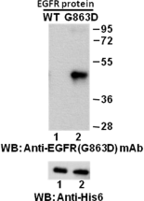
Western blot analysis of recombinant EGFR (G863D) and wildtype proteins. Purified
His-tagged EGFR (G863D) protein (amino acid
702-987) (Cat. #10222) and corresponding
wild-type protein (Cat. #10210) were blotted with anti-EGFR (G863D) mouse monoclonal antibody (Cat. #26119). Proteins loading were blotted with anti-His-tag monoclonal antibody (Cat. #28004).

Immunofluorescence:
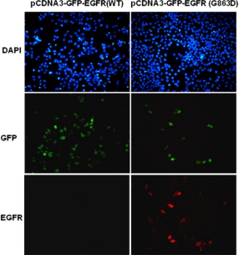
Immunofluorescence of cells expressing EGFR proteins with anti-EGFR (G863D) antibody.
HEK293T cells were transfected with
pCDNA3-GFP-EGFR (WT) plasmid (left column) or pCDNA3-GFP-EGFR (G863D) plasmid (right column), then fixed and stained with anti-EGFR
(G863D) monoclonal antibody (Cat. #26119).

科博瑞（武汉）生物科技有限公司
TEL：027-87615885 15972062685
- mail：3636901710@qq.com
Web:www.coburybio.com

For research use only. Not for diagnostic or therapeutic applications.

