EGFR (N826S)
Catalog Number: CR-M26116
Gene Symbol: EGFR/HER1/ERBB1
Description: Anti-EGFR (N826S) Mouse Monoclonal Antibody

Background: EGFR is a receptor tyrosine
kinase binding ligands ofthe EGF family and activating several signaling cascades to convert extracellular cues into appropriate cellular
responses. It activates at least 4 major
downstream signaling cascades including the RAS-RAF-MEK-ERK, PI3 kinase-AKT,
PLCgamma-PKC and STATs modules. Defects in EGFR are associated with lung cancer
(LNCR).
Immunogen: A synthetic peptide from the internal region of EGFR which includes the mutation of N826S, human origin.
Tested applications: ELISA, WB, IF, IHC Recommended dilutions:
ELISA: 1:1000-1:5000
WB: 1:500-1:1000
IHC: 1:50-1:100
Concentration: 1 mg/ml
Host: Mouse
Clonality: Monoclonal
Purity: Purified from ascites
Format: Liquid Storage buffer:
Preservative: no
Constituents: PBS (without Mg2+ and Ca2+), pH 7.4, 150 mM NaCl, 50% glycerol
Species Reactivity: Recognizes EGFR (N826S), but not wild type EGFR protein from vertebrates. Storage Conditions: Store at -20°C. Avoid
freeze / thaw cycles.

Western blot:
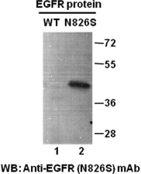

Western blot analysis of recombinant
EGFR(N826S) and wildtype proteins. Purified His-tagged EGFR (N826S) protein (702-987)
(Cat. #10221) and corresponding wild-type
protein (702-987) (Cat. #10210) were blotted
with anti- EGFR (N826S) mouse antibody (Cat.
#26116).

Immunofluorescence:

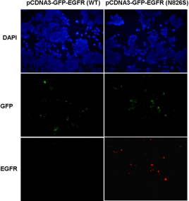

Immunofluorescence of cells expressing EGFR proteins with anti-EGFR (N826S) antibody.
HEK293T cells were transfected with
pCDNA3-GFP-EGFR (WT) plasmid (left column) or pCDNA3-GFP-EGFR (N826S) plasmid (right column), then fixed and stained with anti- EGFR (N826S) monoclonal antibody (Cat. #26116).

科博瑞（武汉）生物科技有限公司
TEL：027-87615885 15972062685
- mail：3636901710@qq.com
Web:www.coburybio.com

