IDH2(R172H)
Catalog Number: CR-M26084
Gene Symbol: IDH2(R172H)
Description: Anti-IDH2(R172H) Mouse Monoclonal Antibody

Background: Isocitrate dehydrogenase (IDH)
catalyze the oxidative decarboxylation of
isocitrate to 2-oxoglutarate. The isocitrate and
isopropylmalate dehydrogenases family has
three members, IDH1, IDH2 and IDH3. IDH2
plays a role in intermediary metabolism and
energy production. Defects in IDH2 are the
cause of D-2-hydroxyglutaric aciduria type 2
(D2HGA2). Somatic mosaic mutations of this
protein have also been found associated to Ollier disease and Maffucci syndrome., and R172H
IDH2 mutations do exist in diffusely infiltrative gliomas.
Immunogen: A synthetic peptide from the internal region ofIDH2 which includes the mutation of R172H, human origin.
Tested applications: ELISA, WB, IHC Recommended dilutions:
ELISA: 1:1000-1:5000
WB: 1:100-1:1000
IHC: 1:50-1:100
IF: 1:50-1:100
Concentration: 1 mg/ml
Host: Mouse
Clonality: Monoclonal
Purity: Purified from ascites
Format: Liquid Storage buffer:
Preservative: no
Constituents: PBS (without Mg2+ and Ca2+), pH 7.4, 150 mM NaCl, 50% glycerol
Species Reactivity: Anti-IDH2(R172H) antibody recognizes IDH2(R172H) of vertebrates.

Storage Conditions: Store at -20°C. Avoid freeze / thaw cycles.

Western blot:
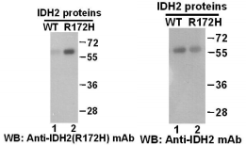
Western blot analysis of recombinant
IDH2(R172H) and wildtype proteins. Purified
His-tagged IDH2(R172H) protein(Cat.#10201) and wildtype protein(Cat.#10200) were blotted with anti-IDH2(R172H) monoclonal
antibody(Cat.# 26084)(left panel). Proteins
loading were blotted with anti-IDH2 monoclonal antibody(right panel).

Immunofluorescence:
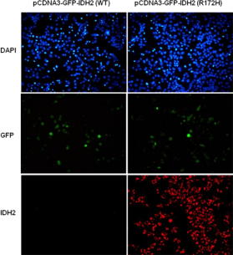
Immunofluorescence of cells expressing IDH2 proteins with anti-IDH2 (R172H) antibody.
HEK293T cells were transfected with
pCDNA3-GFP-IDH2 (WT) plasmid (left column) or pCDNA3-GFP-IDH2 (R172H) plasmid (right
column), then fixed and stained with anti-IDH2 (R172H) monoclonal antibody (Cat. #26084).

科博瑞（武汉）生物科技有限公司
TEL：027-87615885 15972062685
- mail：3636901710@qq.com
Web:www.coburybio.com

For research use only. Not for diagnostic or therapeutic applications.

