IDH1(R132H)
Catalog Number:CR-M 26081
Gene Symbol: IDH1(R132H)
Description: Anti-IDH1(R132H) Mouse Monoclonal Antibody

Background: Isocitrate dehydrogenases
catalyze the oxidative decarboxylation of
isocitrate to 2-oxoglutarate. Mutations affecting Arg-132 are tissue-specific, and suggest that this residue plays a unique role in the development
of high-grade gliomas. Mutations of Arg-132 to Cys, His, Leu or Ser abolish magnesium binding and abolish the conversion of isocitrate to
alpha-ketoglutarate. Instead, alpha-ketoglutarate is converted to R--2-hydroxyglutarate. Elevated levels of R-2-hydroxyglutarate are correlated
with an elevated risk of malignant brain tumors. Immunogen: A synthetic peptide from the
internal region ofIDH1 which includes the mutation of R132H, human origin.
Tested applications: ELISA, WB, IHC Recommended dilutions:
ELISA: 1:1000-1:5000
WB: 1:100-1:1000
IHC: 1:50-1:100
Concentration: 1 mg/ml
Host: Mouse
Clonality: Monoclonal
Purity: Purified from ascites
Format: Liquid Storage buffer:
Preservative: no
Constituents: PBS (without Mg2+ and Ca2+), pH 7.4, 150 mM NaCl, 50% glycerol
Species Reactivity: Anti-IDH1(R132H) antibody recognizes IDH1(R132H) of vertebrates.
Storage Conditions: Store at -20°C. Avoid freeze / thaw cycles

Western blot:
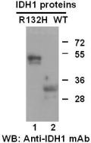
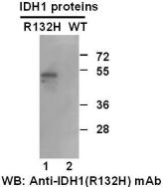

Western blot analysis of recombinant
IDH1(R132H) and wildtype proteins. Purified
His-tagged IDH1 (R132H) protein (Cat. #10199) and wild-type protein (Cat. #10198) were blotted with anti-IDH1(R132H) mouse antibody (Cat.# 26081)(Left panel). Proteins loading were blotted with anti-IDH1 mouse antibody (Cat. #26136,
right panel).

Immunofluorescence:
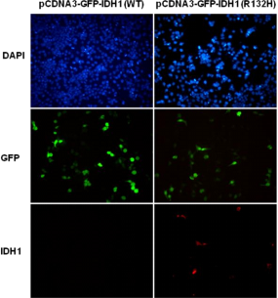
Immunofluorescence of cells expressing IDH1 proteins with anti-IDH1(R132H) antibody.
HEK293T cells were transfected with
pCDNA3-GFP-IDH1 (WT) plasmid (left column) or pCDNA3-GFP-IDH1 (R132H) plasmid (right
column), then fixed and stained with anti-IDH1 (R132H) monoclonal antibody (Cat. #26081).

科博瑞（武汉）生物科技有限公司
TEL：027-87615885 15972062685
- mail：3636901710@qq.com
Web:www.coburybio.com

For research use only. Not for diagnostic or therapeutic applications.

