ERBB2 (V777A)
Catalog Number: CR-M26080
Gene Symbol: ERBB2/HER2/Neu
Description: Anti-ErbB2 (V777A) mouse monoclonal Antibody

Background: The ErbB family is composed of
four plasma membrane-bound receptor tyrosine
kinases. Amplification or over-expression of the ERBB2 gene occurs in approximately 30% of
breast cancers. HER2 is encoded by ERBB2, a
known proto-oncogene located at the long arm of human chromosome 17(17q21-q22). HER2
proteins have been shown to form clusters in cell membranes that may play a role in tumorigenesis. Mutations of ErbB2 protein, including V777A,
have been indicated in human cancers.
Immunogen: A synthetic peptide surrounding the 777A codon ofErbB2 protein.
Tested applications: ELISA, WB, IHC Recommended dilutions:
ELISA WB  IF  IHC | 1:500-1:5000  1:200-1:2000  1:100  1:50-1:100
Concentration: 0.2 mg/ml
Host: Mouse
Clonality: monoclonal
Purity: Purified from serum
Format: Liquid Storage buffer:
Preservative: no
Constituents: PBS (without Mg2+ and Ca2+), pH 7.4, 150 mM NaCl, 50% glycerol
Species Reactivity: Recognizes V777A mutant but not wild type ErbB2 protein, of vertebrates. Storage Conditions: Store at -20°C. Avoid
freeze / thaw cycles

Immunofluorescence:
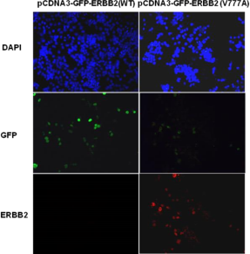

Immunofluorescence of cells expressing ErbB2 proteins with anti-ErbB2 (V777A) antibody.
HEK293T cells were transfected with
pCDNA3-GFP- ErbB2 WT plasmid (left column) or pCDNA3-GFP-ErbB2 (V777A) plasmid (right column), then fixed and stained with anti-ErbB2 (V777A) monoclonal antibody (Cat. #26080).

