TP53(R282W)
Catalog Number: CR-M26076
Gene Symbol: TP53(R282W)
Description: Anti-TP53(R282W) Mouse Monoclonal Antibody

Background: TP53 belongs to the p53 proteins family. It is ubiquitously expressed, acts as a
tumor suppressor in many tumor types and
induces growth arrest or apoptosis depending on the physiological circumstances and cell type.
Defects in TP53 are a cause of esophageal cancer (ESCR), lung cancer (LNCR),
adrenocortical carcinoma (ADCC), choroid plexus papilloma (CPLPA) and so on.
Immunogen: Recombinant TP53(R282W) protein, human origin.
Tested applications: ELISA, WB, IHC Recommended dilutions:
ELISA: 1:1000-1:5000
WB: 1:1000-1:5000
IHC: 1:50-1:100
Concentration: 1 mg/ml
Host: Mouse
Clonality: Monoclonal
Purity: Purified from ascites
Format: Liquid Storage buffer:
Preservative: no
Constituents: PBS (without Mg2+ and Ca2+), pH 7.4, 150 mM NaCl, 50% glycerol
Species Reactivity: Anti-TP53(R282W) antibody recognizes TP53(R282W) of
vertebrates.
Storage Conditions: Store at -20°C. Avoid freeze / thaw cycles

Western blot:
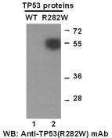
Western blot analysis of recombinant
TP53(R282W) and wildtype proteins. Purified His-tagged TP53(R282W) protein(lane 2,
Cat.#10204) and wild type protein(lane 1,
Cat.#10202) were blotted with anti-TP53
(R282W) mouse monoclonal antibody(Cat. # 26076).

Immunofluorescence:
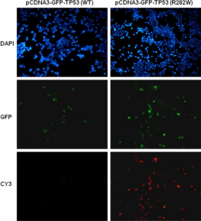
Immunofluorescence of cells expressing TP53 proteins with anti-TP53 (R282W) antibody.
HEK293T cells were transfected with
pCDNA3-GFP-TP53 (WT) plasmid (left column) or pCDNA3-GFP-TP53 (R282W) plasmid (right column), then fixed and stained with anti- TP53 (R282W) monoclonal antibody (Cat. # 26076).

For research use only. Not for diagnostic or therapeutic applications.

科博瑞（武汉）生物科技有限公司
TEL：027-87615885 15972062685
- mail：3636901710@qq.com
Web:www.coburybio.com

