B-Raf (V600E)
Catalog Number:CR-M 26039
Gene Symbol: BRAF, BRAF1, RAFB1
Description: Anti-B-Raf (V600E) Mouse Monoclonal Antibody

Background: B-Raf is a member of the Raf family of Ser/Thr protein kinases. It functions downstream of Ras to regulate the MAP kinase signaling pathway. Mutations in the BRAF gene cause diseases. Inherited mutations in BRAF cause cardiofaciocutaneous syndrome. Acquired mutations in BRAF have been found in cancers
Immunogen: A synthetic peptide from the internal region of Braf (V600E), human origin.
Tested applications: ELISA, WB, IHC, IP Recommended dilutions:
ELISA 1:1000-1:5000
WB 1:500-1:2000
IHC 1:100-1:200
Concentration: 1 mg/ml
Host: Mouse
Clonality: Monoclonal
Isotype: IgG
Purity: Purified from ascites
Format: Liquid Storage buffer:
Preservative: no
Constituents: PBS (without Mg2+ and Ca2+), pH 7.4, 150 mM NaCl, 50% glycerol
Species Reactivity: Recognizes V600E mutated, but not wild-type B-Raf proteins from vertebrates. Storage Conditions: Store at -20°C. Avoid freeze / thaw cycles.

Western blot:

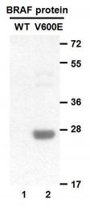
Western blot analysis of recombinant B-raf proteins. Purified His-tagged B-Raf(V600E) protein (amino acids 513-693, lane 2) and corresponding wild type protein (lane 1) were blotted with anti-B-Raf(V600E) monoclonal antibody (Cat. # 26039).

Immunofluorescence:

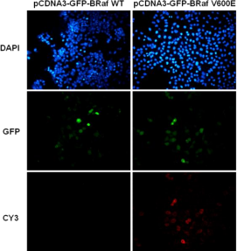

Immunofluorescence of cells expressing B-Raf (V600E) protein with anti-B-Raf (V600E)
antibody. HEK293T cells were transfected with pCDNA3-GFP-B-Raf WT plasmid (left column) or pCDNA3-GFP-B-Raf V600E plasmid (right column), then fixed and stained with anti- B-Raf (V600E) monoclonal antibody (Cat. # 26039).

Immunohistochemistry:
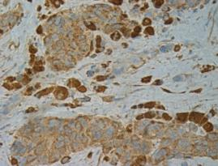
Immunohistochemical analysis of
paraffin-embedded human melanoma tissue
with anti-B-Raf (V600E) monoclonal antibody (Cat. # 26039). Tissue samples were fixed with formaldehyde and blocked with 1% serum for 15 min at 37 °C. Antigen retrieval was by heat
mediation in citrate buffer (pH6). Samples were then incubated with primary antibody (1:100)
overnight at 4°C. A HRP-conjugated Goat
anti-mouse IgG (dilution 1:50) was used as secondary antibody.
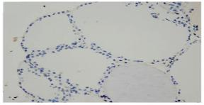
Immunohistochemical analysis of paraffin
embedded Thyroid Carcinoma tissue -withanti
BRaf(V600E) monoclonal antibody (Cat. # 26039 ). Tissue samples were fixed withparaffin.
Samples were then incubated with primary
antibody (1:100) overnight at 4°C. A HRP-
conjugated Goat anti-mouse IgG (dilution 1:50) was used as secondary antibody.Allele specific PCR validated to be Negative for BRAF V600E.

For research use only. Not for diagnostic or therapeutic applications.

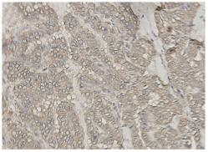
Immunohistochemical analysis of paraffin embedded Thyroid Carcinoma tissue -with anti BRaf(V600E) monoclonal antibody
(Cat. # 26039). Tissue samples were fixed withparaffin. Samples were then incubated with primary antibody (1:100) overnight at 4°C. A HRP-conjugated Goat anti-mouse IgG (dilution 1:50) was used as secondary antibody. Allele specific PCR validated to be Negative for BRAF V600E.

Publications:
1. John K Feller, Shi Yang and Meera Mahalingam. Immunohistochemistry with a mutation-specific
monoclonal antibody as a screening tool for the
BRAFV600E mutational status in primary cutaneous malignant melanoma. Modern Pathology. 2012.
doi:10.1038/modpathol.2012.168

科博瑞（武汉）生物科技有限公司
TEL：027-87615885 15972062685
- mail：3636901710@qq.com
Web:www.coburybio.com

