Ras(G13D)
Catalog Number: CR-M26038
Gene Symbol: RAS (G13D)
Description: Anti-Ras (G13D) Mouse Monoclonal Antibody

Background: K-Ras G13D mutation, which
occur at codons 13, prevent efficient GTP
hydrolysis and thus render the proteins in an
activated state. As a result, multiple Ras effector pathways which control fundamental biological processes such as proliferation, apoptosis, and
cell motility become constitutively activated
and/or deregulated. K-Ras (G13D) is involved in tumor initiation and progression.
Immunogen: Recombinant full length protein of K-Ras (G13D).
Tested applications: ELISA, WB, IHC Recommended dilutions:
ELISA 1:100-1:5000
WB 1:100-1:1000
IHC 1:50-1:100
Concentration: 1 mg/ml
Host: mouse
Clonality: Monoclonal
Isotype: IgG2b
Purity: Purified from ascites
Format: Liquid Storage buffer:
Preservative: no
Constituents: PBS (without Mg2+ and Ca2+), pH 7.4, 150 mM NaCl, 50% glycerol
Species Reactivity: RasG13D antibody
recognizes RasG13D proteins of vertebrates. Storage Conditions: Store at -20°C. Avoid freeze / thaw cycles

Western blot:
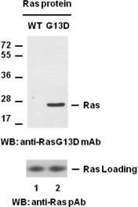

Western blot analysis of recombinant K-Ras WT and G13D proteins with anti-Ras(G13D) monoclonal antibody. Equal amount of purified Ras WT (lane 1, Cat# 10172) and G13D (lane 2, Cat. # 10155) proteins were loaded and blotted with anti-RasG13D mouse monoclonal
antibody(Cat. # 26038)(top panel). Input
control(bottom panel) was blotted with rabbit polyclonal anti-Ras antibody (Cat. # 21021).

Immunofluorescence:
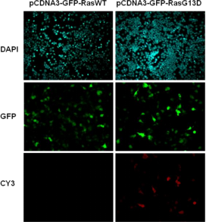
Immunofluorescence of cell expressing
Ras(G13D) protein with anti-Ras(G13D)
antibody. HEK293T cells were transfected with pCDNA3-GFP-Ras(WT) plasmid (left column) or pCDNA3-GFP-Ras(G13D) plasmid (right
column), then fixed and stained with
anti-Ras(G13D) monoclonal antibody (Cat. # 26038).

For research use only. Not for diagnostic or therapeutic applications.

