

Active Ran
Catalog Number: CR-M26915
Gene Symbol: RAN
Description: Anti-Active Ran Mouse Monoclonal Antibody

Background: Ran (Ras-related nuclear protein) is a member ofthe Ras-superfamily GTPases. Ran is
invovled in the transport of proteins across the nuclear envelope, as well as in microtubule
organization during mitosis.
Immunogen: Recombinant full length protein of active Ran.
Tested applications: IP, IHC Recommended dilutions:
1 μg for 1~2 mg total cellular proteins for IP;
1:100 dilution for IHC Concentration: 1 mg/ml Host: mouse
Clonality: Monoclonal
Isotype: IgG
Purity: Purified from ascites
Format: Liquid Storage buffer:
Preservative: no
Constituents: PBS (without Mg2+ and Ca2+), pH 7.4, 150 mM NaCl, 50% glycerol
Species Reactivity: Anti-active Ran antibody recognizes active Ran of vertebrates.
Storage Conditions: Store at -20°C. Avoid freeze / thaw cycles

Immunoprecipitation/Western blot

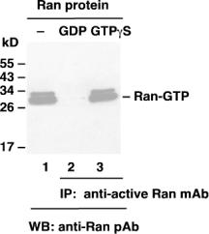

Ran activation assay. Purified Ran proteins were loaded as a control (lanes 1) or immunoprecipitated after treated with GDP (lane 2) or GTPγS (lane 3). Immunoprecipitation was done with the anti-active Ran monoclonal antibody (Cat. No. 26915). Immunoblot was with an anti-Ran polyclonal antibody.

For research use only. Not for diagnostic or therapeutic applications.

Tel: 027-87615885 15972062685
E-mail：3636901710@qq.com
Web: http://www.coburybio.com

