

Active Cdc42
Catalog Number: CR-M26905
Gene Symbol: CDC42
Description: Anti-Active Cdc42 Mouse Monoclonal Antibody

Background: Small GTPases are a super-family of cellular signaling regulators. Cdc42 belongs to the Rho sub-family of GTPases that regulate cell motility, cell division, and gene transcription. GTP binding increases the activity of Cdc42,
and the hydrolysis of GTP to GDP renders it inactive. GTP hydrolysis is aided by GTPase activating proteins (GAPs), while exchange of GDP for GTP is facilitated by guanine
nucleotide exchange factors (GEFs).

Immunogen: Recombinant full length protein of active Cdc42
Tested applications: IP, IHC Recommended dilutions:
1 µg for 1~2 mg total cellular proteins Concentration: 1 mg/ml
Host: Mouse
Clonality: Monoclonal
Purity: Purified from ascites
Format: Liquid Storage buffer:
Preservative: no
Constituents: PBS (without Mg2+ and Ca2+), pH 7.4, 150 mM NaCl, 50% glycerol
Species Reactivity: Anti-active Cdc42 antibody recognizes active Cdc42 from vertebrates.
Storage Conditions: Store at -20°C. Avoid freeze / thaw cycles.

IP-Western blot:
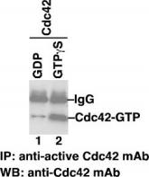
IP/WB analysis of active Cdc42 protein. Purified recombinant Cdc42 proteins were loaded with GDP (lane 1) or GTPgS (lane 2). These proteins were immunoprecipitated with anti-active Cdc42 mouse monoclonal antibody (Cat. # 26905). After SDS/PAGE, the membrane filter was probed with anti-Cdc42 mouse monoclonal antibody (Cat. # 26008).

For research use only. Not for diagnostic or therapeutic applications.

Tel: 027-87615885 15972062685
E-mail：3636901710@qq.com
Web: http://www.coburybio.com

Immunofluorescence:
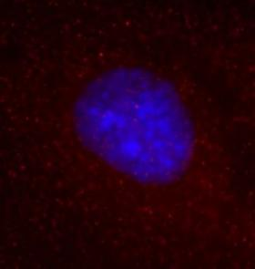
Immunofluorescent labeling of Cdc42-GTP in MS1 mouse endothelial cells. The MS1 cells cultured on glass coverslips (Fisher) in DMEM containing 5% FBS were fixed with 4% paraformaldehyde for 10 minutes at RT (room temperature) and permeablized in PBSN (PBS+0.1%NP40) for 15 minutes at RT. The cells were stained with primary antibody (Cdc42-GTP) at 1:25 dilution in Invitrogen's CAS-BLOCK (00-8120) reagent at RT for 1 hour. After brief washing in PBSN (3x5min), a secondary Alexa555 conjugated goat anti mouse antibody (Invitrogen A21424) was applied in 1:200 in CAS-BLOCK at RT for 1 hour. The coverslips were then washed in PBSN (3x5min) and mounted using vectorsheld's hard set mounting medium (H-1500), and examined using a Zeiss inverted epifluorescent miscroscope.

