Active Rac1
Catalog Number: CR-M26903
Gene Symbol: RAC1
Description: Anti-Active Rac Mouse Monoclonal Antibody

Background: Small GTPases are a super-family of cellular signaling regulators. Rac belongs to the Rho sub-family of GTPases that regulate cell motility, cell division, and gene transcription.
GTP binding increases the activity of Rac, and the hydrolysis of GTP to GDP renders it inactive.
GTP hydrolysis is aided by GTPase activating
proteins (GAPs), while exchange of GDP for GTP is facilitated by guanine nucleotide exchange
factors (GEFs).
Immunogen: Recombinant full length protein of active Rac1
Tested applications: IP, IHC Recommended dilutions:
1 μg for 1~2 mg total cellular proteins Concentration: 1 mg/ml
Host: mouse
Clonality: Monoclonal
Isotype: IgM
Purity: Purified from ascites
Format: Liquid Storage buffer:
Preservative: no
Constituents: PBS (without Mg2+ and Ca2+), pH 7.4, 150 mM NaCl, 50% glycerol
Species Reactivity: Anti-active Rac1 antibody recognizes active Rac1 from vertebrates.
Storage Conditions: Store at -20°C. Avoid freeze / thaw cycles

Immunoprecipitation and Western blot:
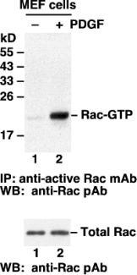

Rac activation assay. MEF cells were treated
with (lane 2) or without (lane 1) PDGF. Cell
lysates were incubated with an anti-active Rac
monoclonal antibody (Cat # 26903) (top panel). The precipitated active Rac was immunoblotted with an anti-Rac rabbit polyclonal antibody (Cat # 21003). The bottom panel shows the Western blot with anti-Rac of the cell lysates used (5% of that used in the top panel).

Immunohistochemistry:

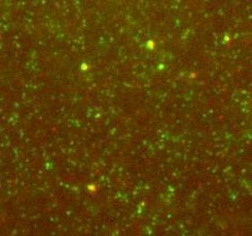

Immunohistochemistry for the active Rac using
Anti-Active Rac1-GTP Mouse Monoclonal
Antibody [26903] shows Rac-GTP
immunolabeling (green) in combination with
cofilin (red) on brain tissue sections. The tissue
sections were fixed with -20 ºC methanol or 4% paraformaldehyde (fixation time 1hr) and stained with antibody at 1:1000 in 0.1M Phosphate buffer with 0.3% Triton X, and 4% BSA for 24h at room temperature. Secondary antibodies were
anti-mouse AlexaFluor488 and anti-rabbit AlexaFluor594 at 1:1000.

