

Active Gαi
Catalog Number: CR-M26901
Gene Symbol: Gnai
Description: Anti-Active Gαi Mouse Monoclonal Antibody

Background: Heterotrimeric G proteins are critical cellular signal transducers. Gαi represents one
sub-family of G proteins that could mediate the
inhibition of adenylyl cyclases. Other biochemical and physiological functions of Gαi proteins are
being explored.
Immunogen: Recombinant full length protein of active Gαi1
Tested applications: IP, IHC Recommended dilutions:
1 μg for 1~2 mg total cellular proteins Concentration: 1 mg/ml
Host: mouse
Clonality: Monoclonal
Isotype: IgG1
Purity: Purified from ascites
Format: Liquid Storage buffer:
Preservative: no
Constituents: PBS (without Mg2+ and Ca2+), pH 7.4, 150 mM NaCl, 50% glycerol
Species Reactivity: Anti-active Gαi antibody recognizes active Gαi1, Gαi2, and Gαi3 of
vertebrates.
Storage Conditions: Store at -20°C. Avoid freeze / thaw cycles

Immunoprecipitation/Western blot
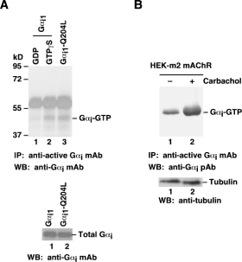
Gαi activation assay. A. CHO cells were transfected
with wild-type Gαi1 (lanes 1 and 2) or constitutively active Gαi1-Q204L (lane 3). Cell lysates were treated with GDP (lane 1) or GTPγS (lane 3). Lysates were then incubated
with an anti-active Gαi monoclonal antibody (Cat. No.
26901) (top panel). The precipitated active Gαi was
immunoblotted with an anti- Gαi monoclonal antibody (Cat. No. 26003). The bottom panel shows the Western blot with anti- Gαi monoclonal antibody (Cat.No. 26003) of the cell lysates. B. HEK293 cells stably expressing human m2
mAChR were treated with (lane 2) or without (lane 1)
carbachol. Cell lysates were then incubated with an
anti-active Gαi monoclonal antibody (Cat. No. 26901) (top panel). The precipitated active Gαi was immunoblotted with an anti- Gαi rabbit polyclonal antibody (Cat. No.
21006). The bottom panel shows the Western blot with anti-tubulin of the cell lysates..

For research use only. Not for diagnostic or therapeutic applications.
Tel: 027-87615885 15972062685 E-mail：3636901710@qq.com
Web: http://www.coburybio.com

